# **CprE 381: Computer Organization and Assembly-Level Programming**

# **Project Part 2 Report**

Team Members: Sam Burns, Isaiah Aldiano

## Project Teams Group #: A_01

***Refer to the highlighted language in the project 1 instruction for the context of the following questions****.*

[1.a] Come up with a global list of the datapath values and control signals that are required during each pipeline stage.

IF: Jump, Branch, JR

ID: RegDst, sRegWr, JAL, SignExtend, ALUSrc

EX: Branch, BNE, Jump, JR, Overflow

Mem: MemWr

WB: Halt, MemtoReg,LB, LH, LHU

[1.b.ii] high-level schematic drawing of the interconnection between components.

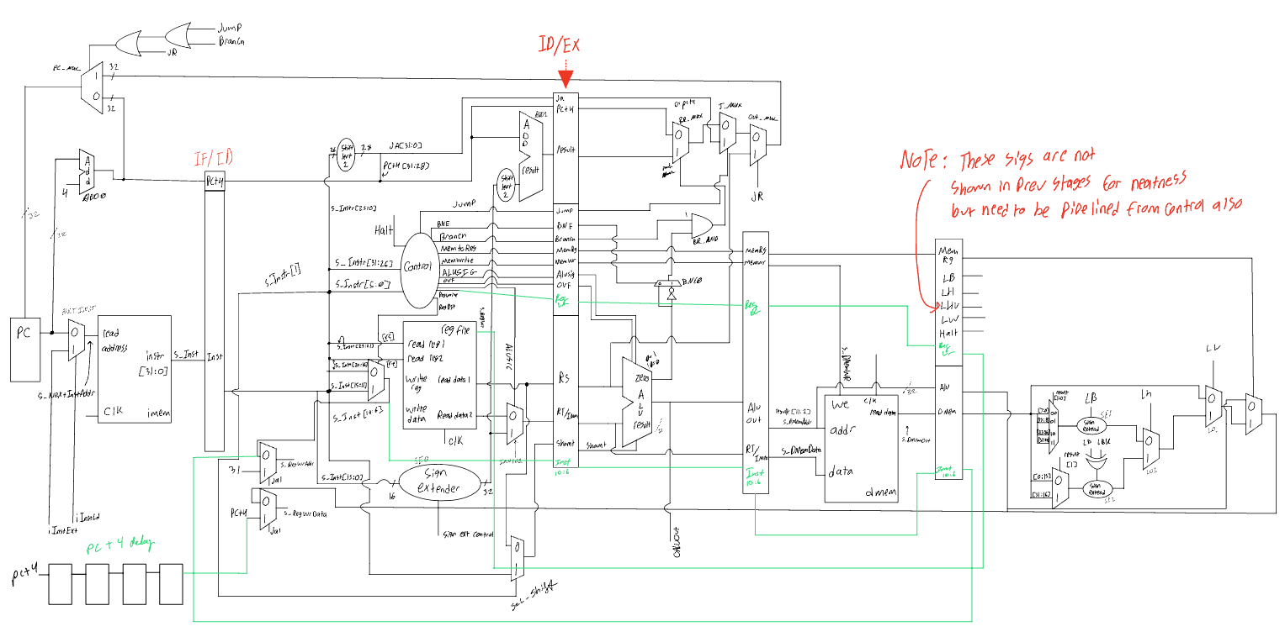

[1.c.i] include an annotated waveform in your writeup and provide a short discussion of result correctness.

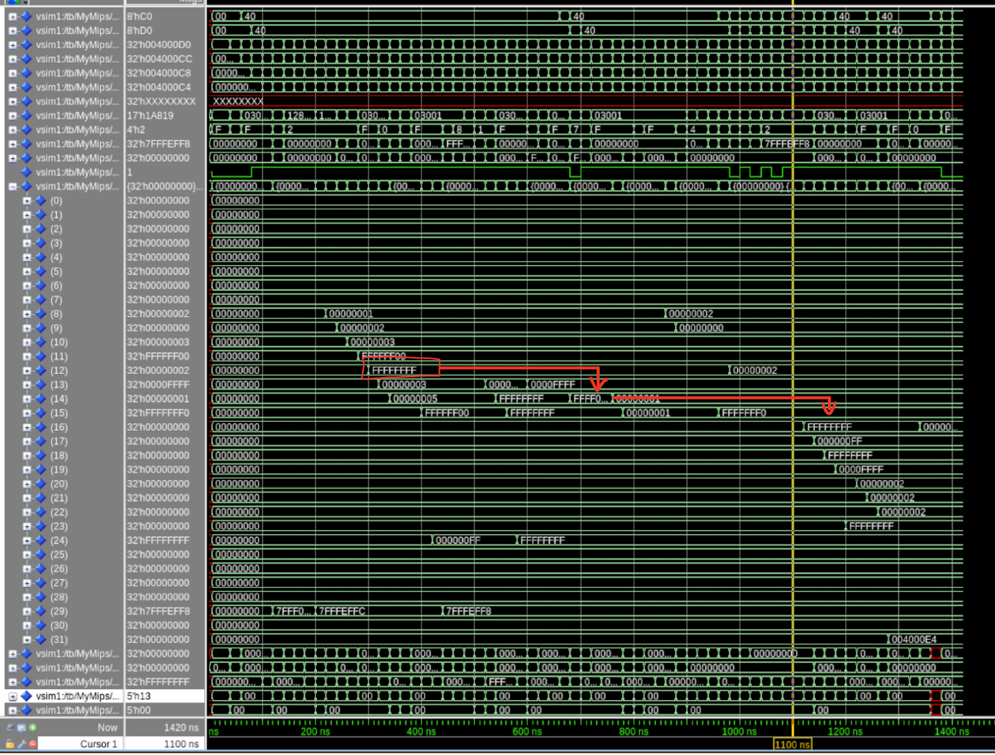

AT 300ns 0xFFFFFFFF is stored into register 12. 680ns register 12 is stored onto stack that has already been decremented. 1000ns - 1270ns 0xFFFFFFFF stored on the stack pointer is used to for lb, lbu, lh, lhu, and lw into registers 16,17,18,19, and 23

[1.c.ii] Include an annotated waveform in your writeup of two iterations or recursions of these programs executing correctly and provide a short discussion of result correctness. In your waveform and annotation, provide 3 different examples (at least one data-flow and one control-flow) of where you did not have to use the maximum number of NOPs.

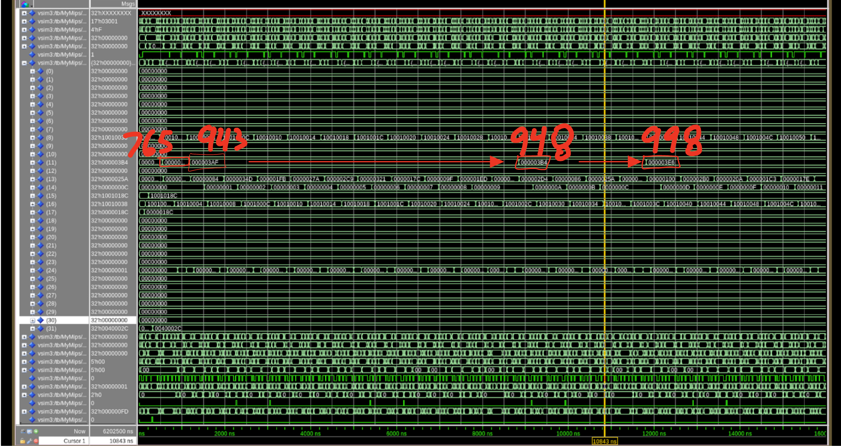

Our bubble sort program shows how an array of numbers is iterated over and finds the current max value. Register 11 holds the max value till the end of the array is reached then the program starts over from the beginning of the array

[1.d] report the maximum frequency your software-scheduled pipelined processor can run at and determine what your critical path is (specify each module/entity/component that this path goes through).



Our critical path for this software pipelined processor is traced through the ALU and through the end of our fetch logic, according to the timing report as follows. An internal trace of the path through the alu is shown to complement the trace of the top level schematic.

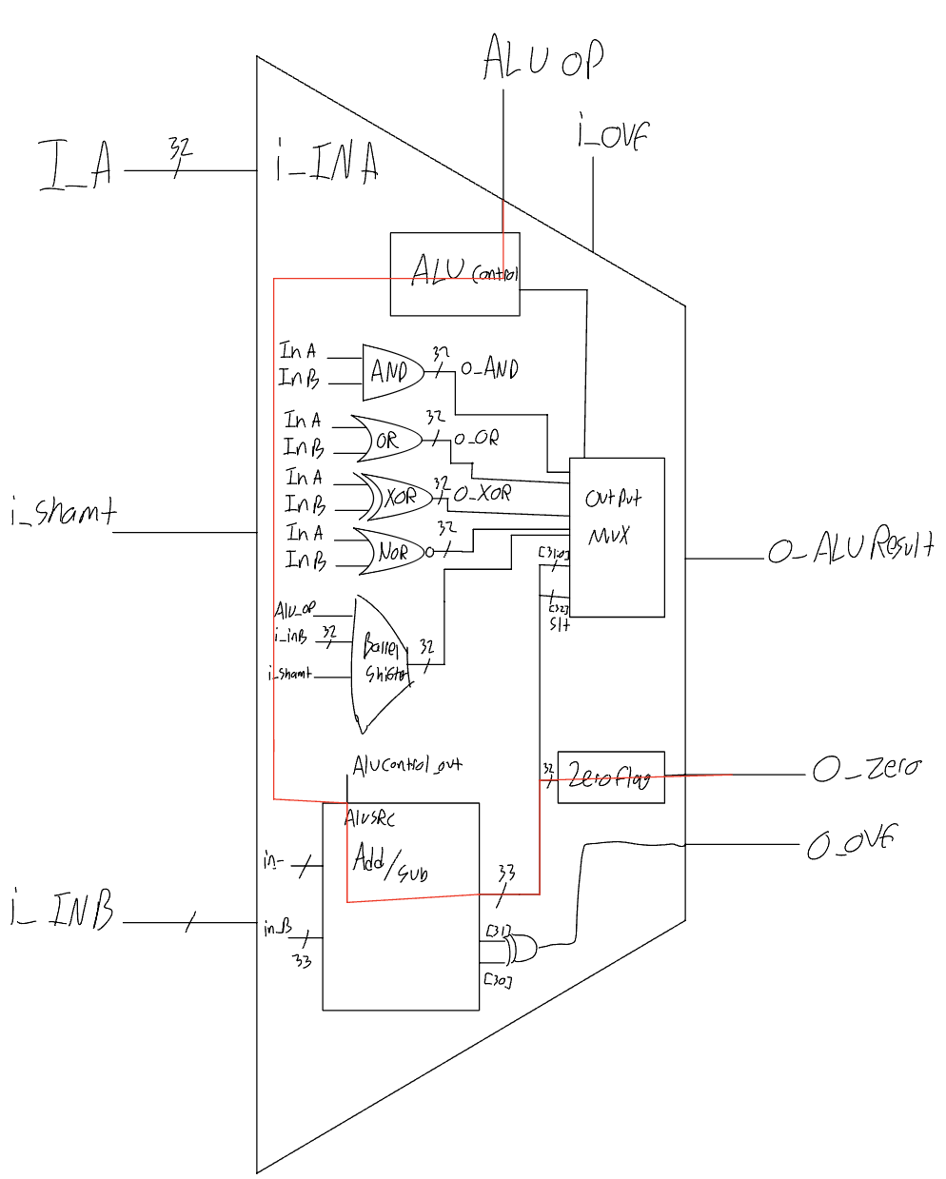

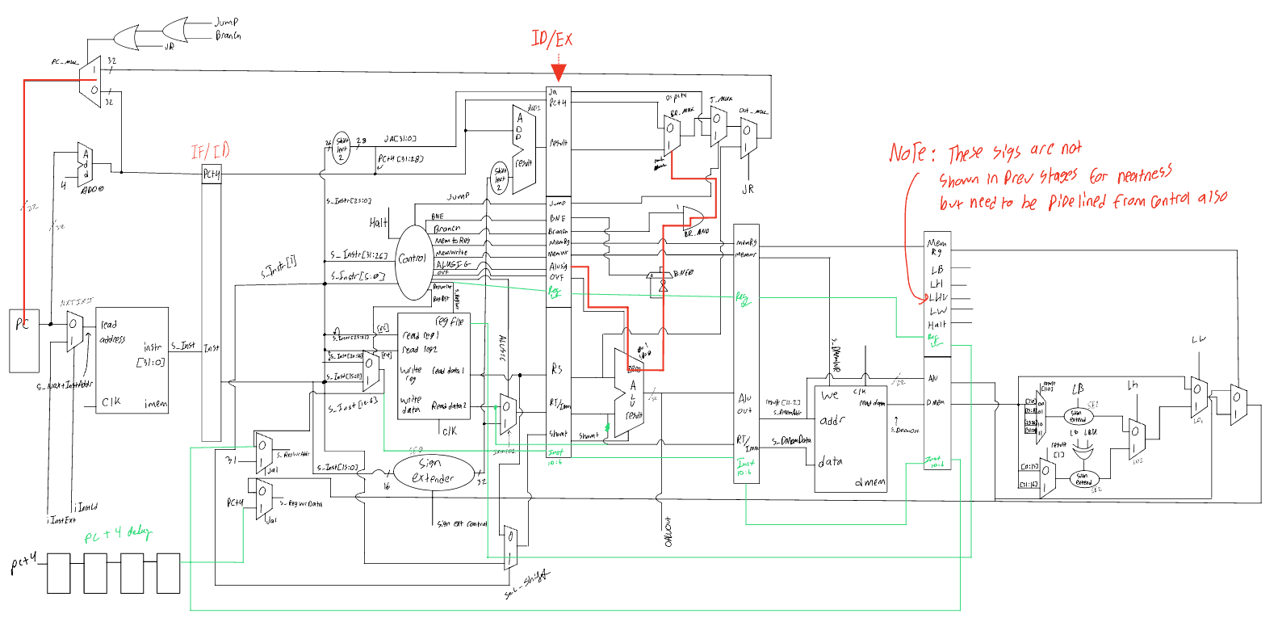

[2.a.ii] Draw a simple schematic showing how you could implement stalling and flushing operations given an ideal N-bit register.

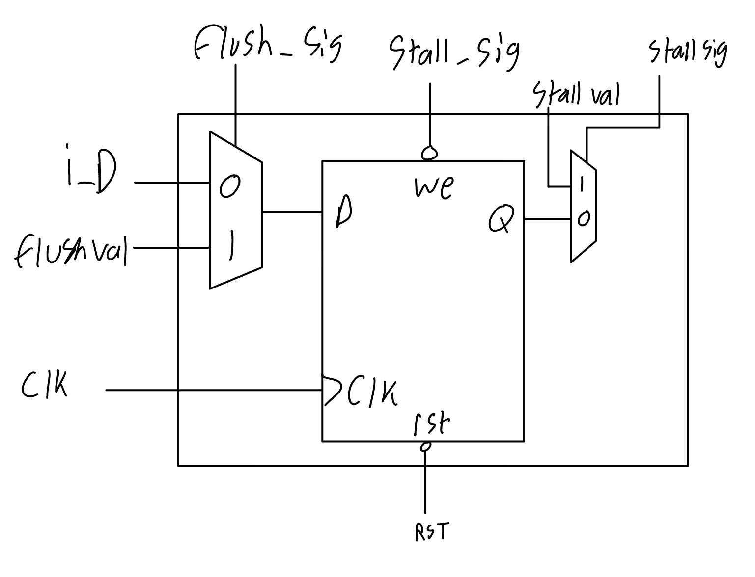

[2.a.iii] Create a testbench that instantiates all four of the registers in a single design. Show that values that are stored in the initial IF/ID register are available as expected four cycles later, and that new values can be inserted into the pipeline every single cycle. Most importantly, this testbench should also test that each pipeline register can be individually stalled or flushed.

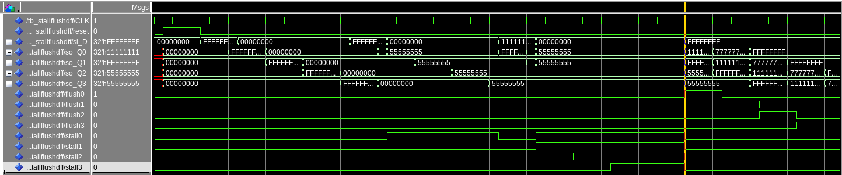

In the testbench above

[2.b.i] list which instructions produce values, and what signals (i.e., bus names) in the pipeline these correspond to.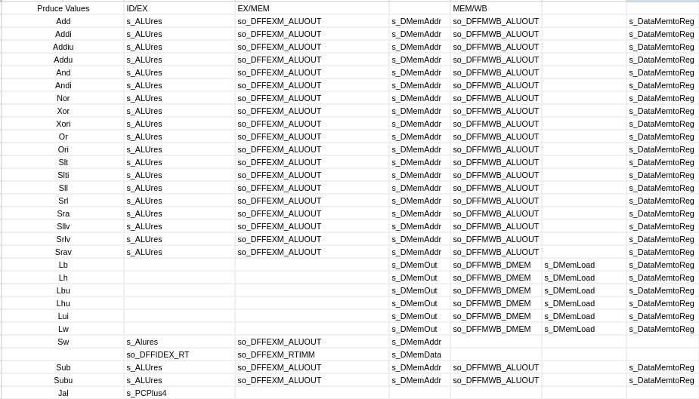

[2.b.ii] List which of these same instructions consume values, and what signals in the pipeline these correspond to.

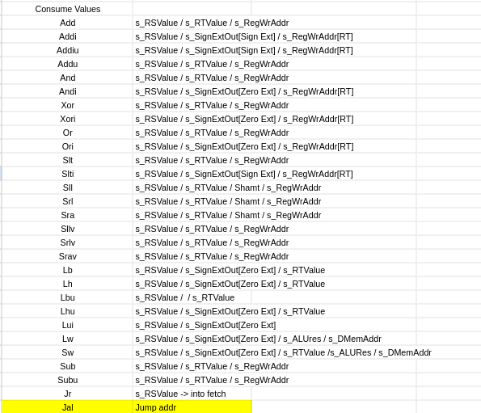

[2.b.iii] generalized list of potential data dependencies. From this generalized list, select those dependencies that can be forwarded (write down the corresponding pipeline stages that will be forwarding and receiving the data), and those dependencies that will require hazard stalls.

If an instruction is writing to a register but the instruction following uses the result of the ALU. The result can forwarded MEM -> EX to be used before being written to reg file

If a load instruction is followed by an instruction that uses the register expecting a load value we stall EX for one stage to allow for load value to propagate and be forwarded WB -> EX

If an instruction writes to a register is followed by a load instruction that uses the previously written value as the

[2.b.iv] global list of the datapath values and control signals that are required during each pipeline stage

ID

* ALUsrc, regdst, sign extender

EX

* jump, BNE, Branch, Memtoreg, Memwrite, ALUsig, ovf

MEM

* dmemwr

WB

* JAL, memtorg, lb, lh, lhu, lw,

[2.c.i] list all instructions that may result in a non-sequential PC update and in which pipeline stage that update occurs.

Jump: EX

JumpReg: EX

Jal: EX

BEQ: EX

BNE: EX

[2.c.ii] For these instructions, list which stages need to be stalled and which stages need to be squashed/flushed relative to the stage each of these instructions is in.

For both jumping and branching we have to flush ID and IF stages. Instructions continue from EX, MEM, and WB continue through the processor and finish with DMEM or register writes

[2.d] implement the hardware-scheduled pipeline using only structural VHDL. As with the previous processors that you have implemented, start with a high-level schematic drawing of the interconnection between components.

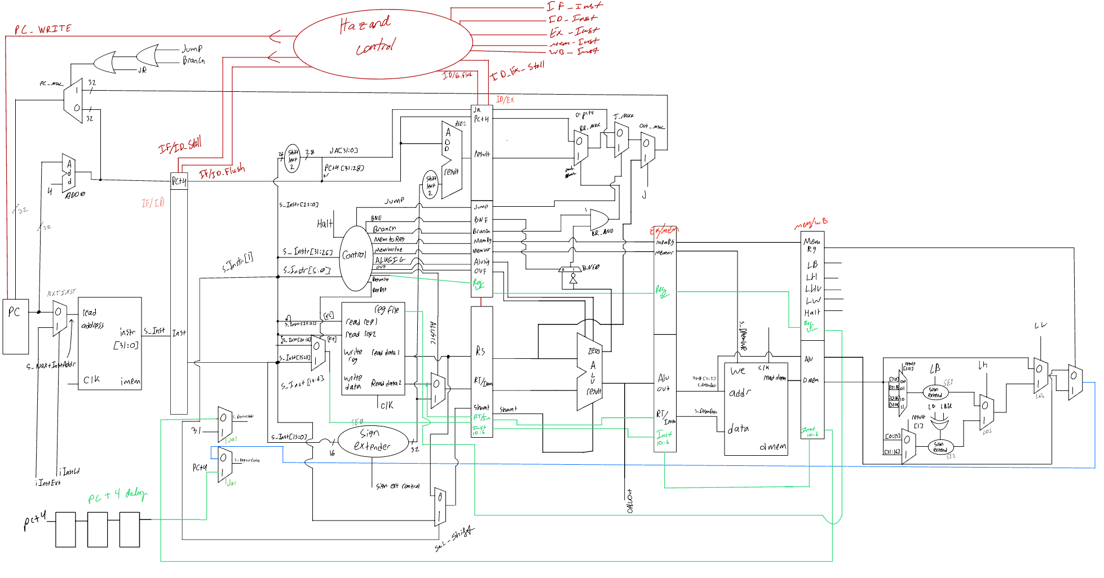

[2.e – i, ii, and iii] In your writeup, show the QuestaSim output for each of the following tests, and provide a discussion of result correctness. It may be helpful to also annotate the waveforms directly.

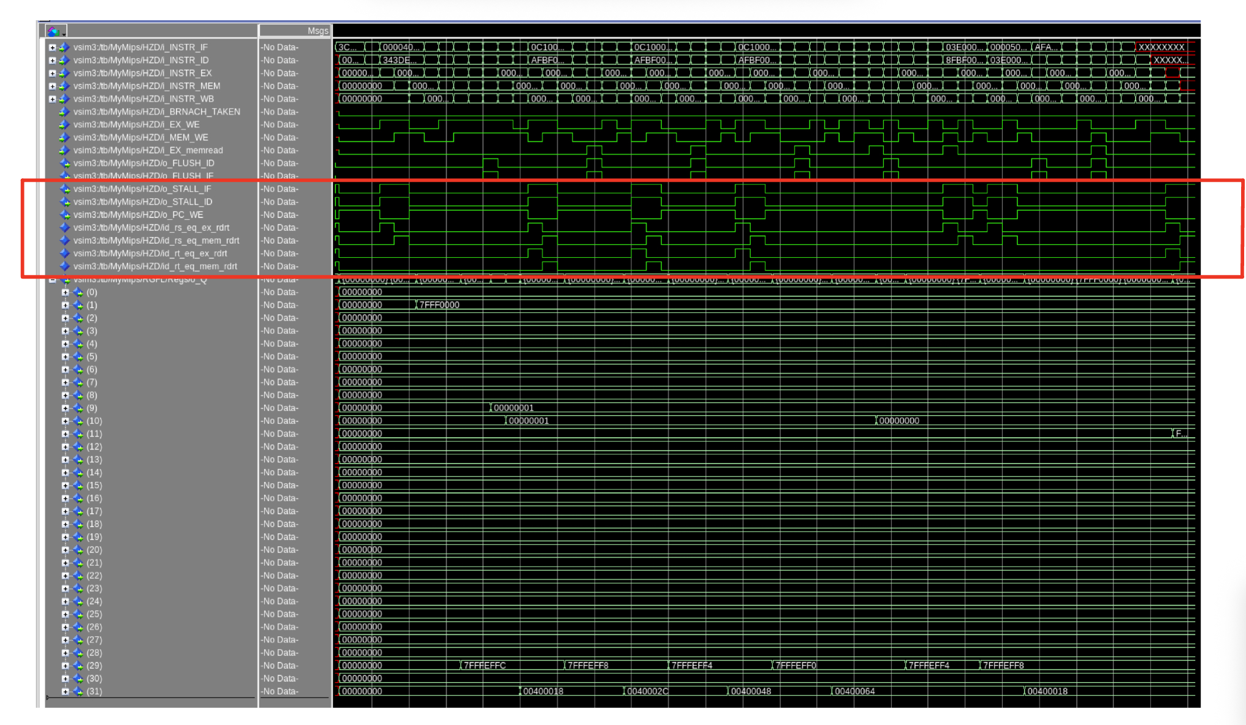

Jaljr.s

In jaljr.s the stack pointer is initialized and set to the correct value. The program jumps down to different labels while decrementing the stack pointer and pushing the current $ra value onto the stack. Once the final jal is performed and the last label is reached the jr instruction jumps backs back the value stored in $ra. The current stack pointer value is then zeroed out, the stack pointer is incremented, and the next stack pointer value is loaded back into $ra. Once this reaches back the to first label the program jumps to exit. Our waveforms show an accurate performance of our processor by stalling when a data hazard is detected and flushing the IF and ID instructions when a jal, jr, or j occurs.

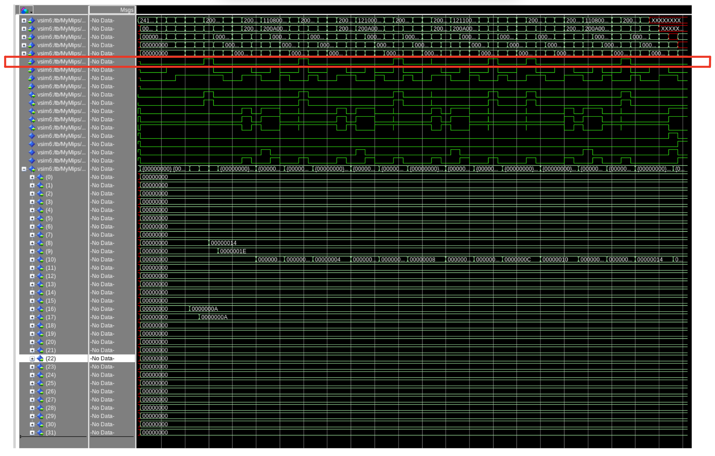

beqtests.s

In beqtests there are four initial values 10, 10, 20, 30 loaded into registers to perform comparisons when using the beq instruction. After beq instructions there are addi immediate instructions that change the value of $t2. Depending on if the branch equals is taken or not changes the value written to register $t2. Some addi instructions are skipped because the beq prior to them is taken. Likewise, some addi instructions are executed because the beq prior to them is not taken and the pc increments as normal. Our waveforms provide an accurate representation of this program working correctly by flushing both if and id when the BRANCH_TAKEN value is set to 1.

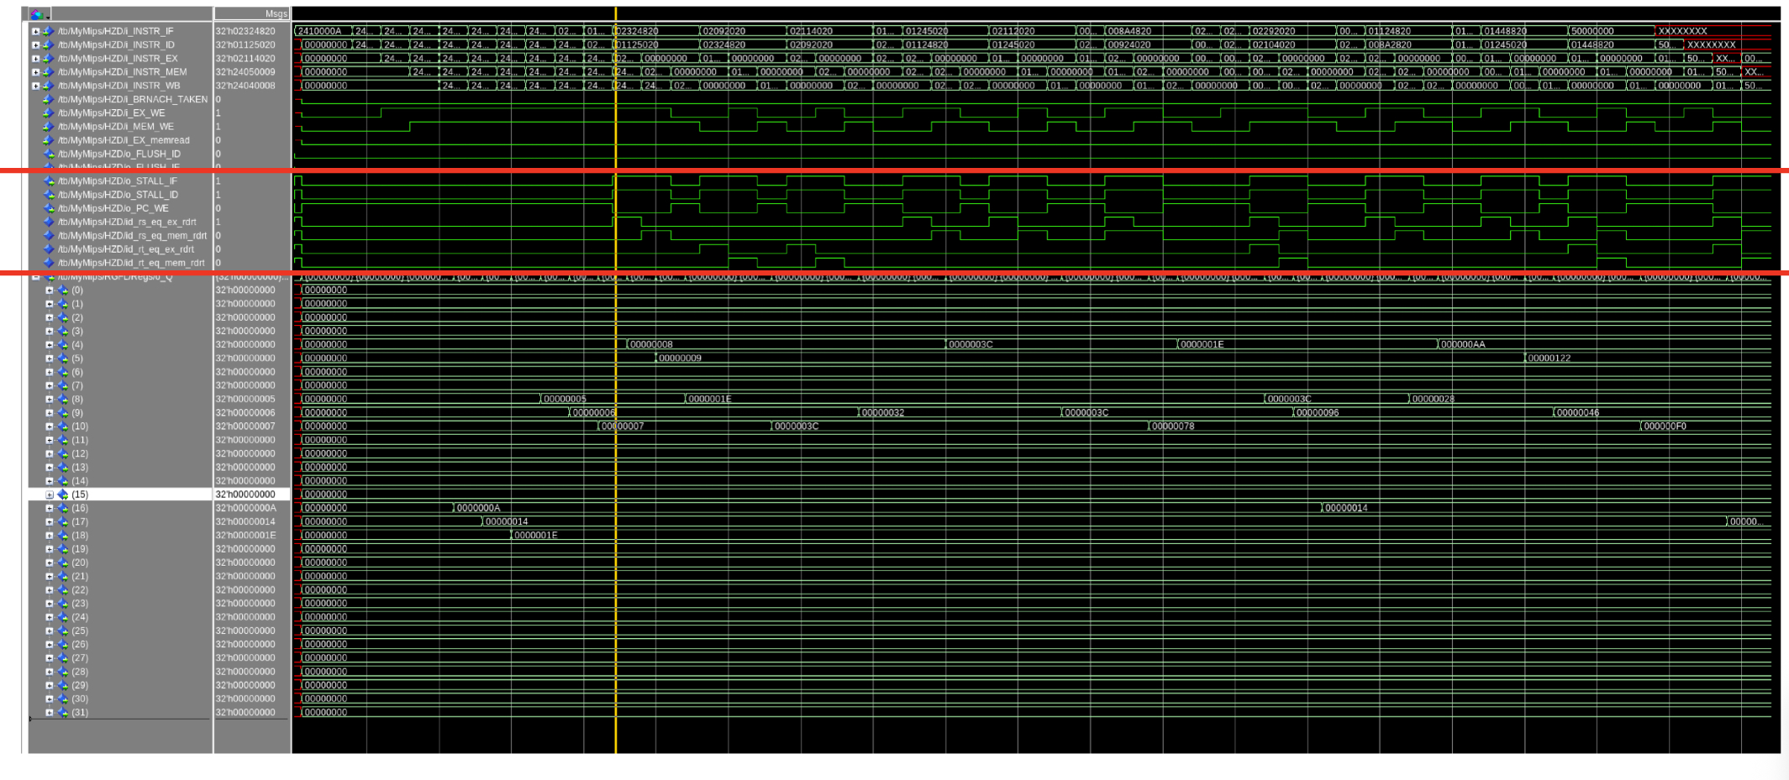

rdexmem_eq_rsrtid.s

In this mips program nine values are initially loaded registers to be used for adding instructions. This program takes the rd value of an add instruction and uses it as the rs and/or rt value of the following add instruction. Our waveforms show that the IF and ID stall signals output a value for when our processor detects a data hazard in the id stage from the ex or mem stage.

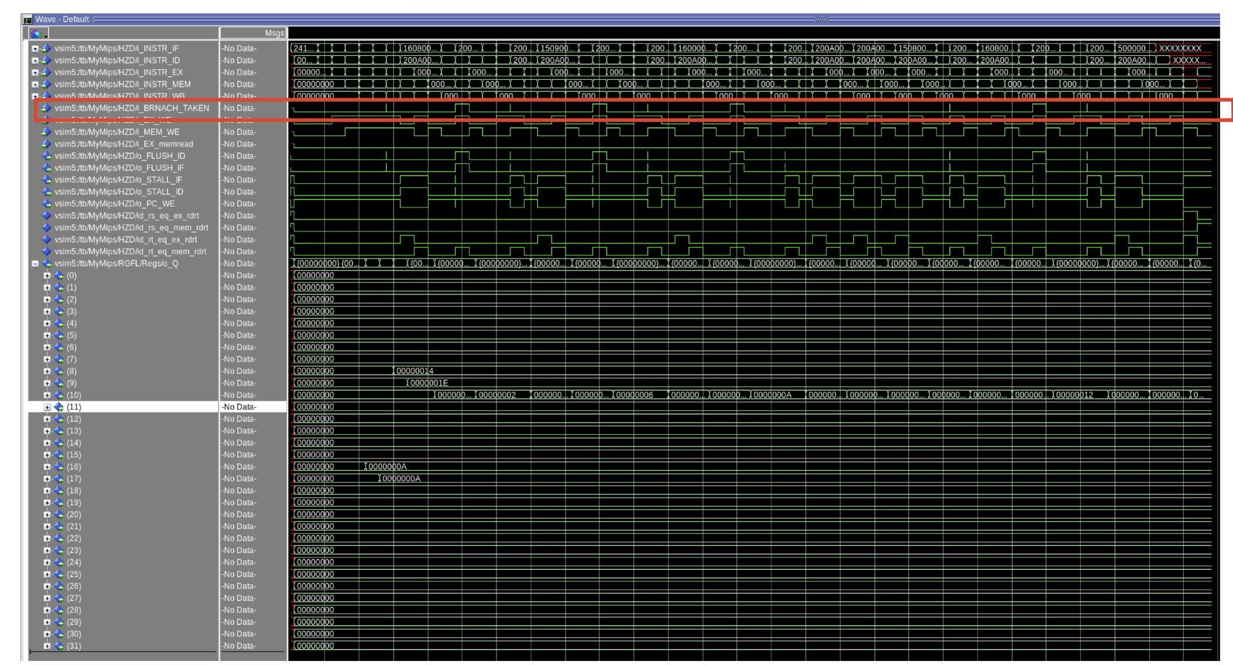

bnetests.s

In bnetests there are four initial values 10, 10, 20, 30 loaded into registers to perform comparisons when using the bne instruction. After bne instructions there are addi immediate instructions that change the value of $t2. Depending on if the branch not equals is taken or not changes the value written to register $t2. Some addi instructions are skipped because the bne prior to them is taken. Likewise, some addi instructions are executed because the bne prior to them is not take and the pc increments as normal. Our waveforms provide an accurate representation of this program working correctly by flushing both if and id when the BRANCH_TAKEN value is set to 1.

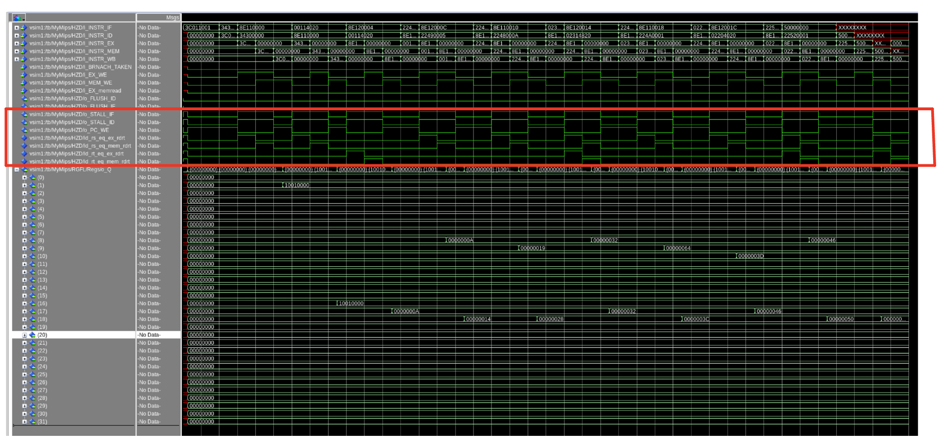

Loaduse.s

In loaduse.s there is an array initialized with the values 10 through 80 incrementing by 10s. Load word instructions are followed by add/i that use the rt of the load word instruction as an rs/rt value in the adds. The load word values are selected with an immediate offset to select different values from the array. Our processor correctly handles this by stalling the if and id stages and allowing the value to load from dmem to the registers. Our waveforms show this correctly by showing the correct add values in the correct registers and by sending stall and pc write enable signals correctly.

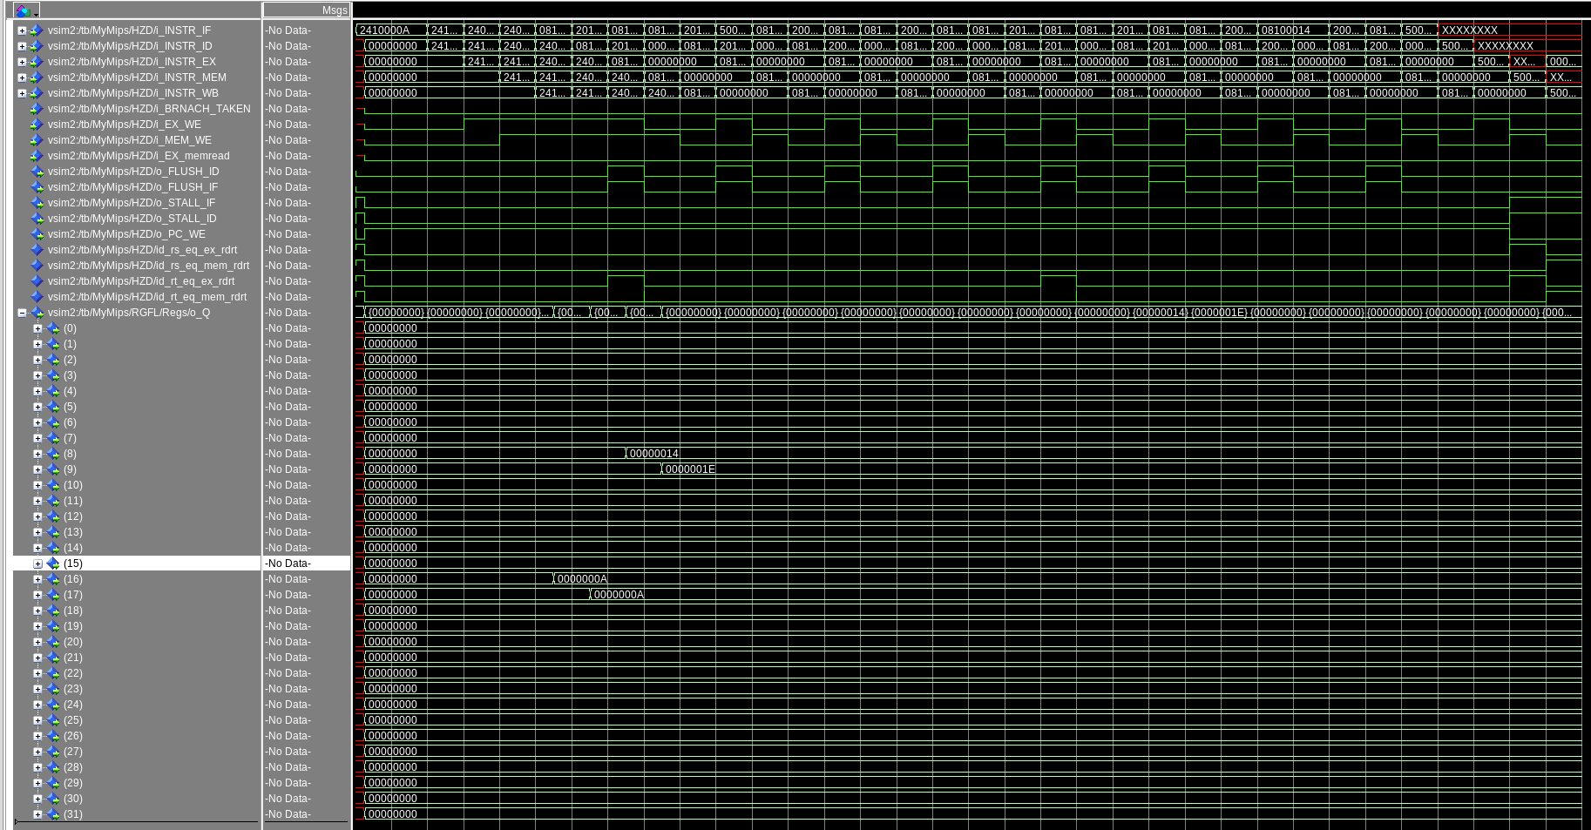

Jumptests.s

In jumptests there are four registers initialized with values 10, 20, 30, 40 at the beginning of the program. Directly after every jump there is an add reg, $zero, 1 that would reset them to the value of 1 if they reached the execute and write back stage. Instead due to our processor performing jumps in the execute stage and hazard unit working correctly the values remain the same through the entire program. When our processor detects a jump instruction it allows the ex, mem, and wb instructions to percolate through the processor and squashes the instructions in if and id. In the waveform we can see that the values are unchanged through the program and that FLUSH_ID/IF flush the if and id stage correctly.

[2.f] report the maximum frequency your hardware-scheduled pipelined processor can run at and determine what your critical path is (specify each module/entity/component that this path goes through).



